The Tribe Parenting Circle at Nurture
Friday 9:30am – 12pm, 131 Hill Street Newtown (Back Deck)
Dates for 2019 - 12 April, 10 May, 7 June, 5 July, 2 August, 30 August
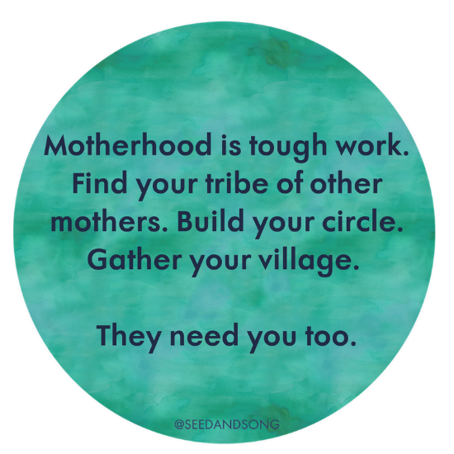
We are pleased to announce The Tribe Parenting Circle at Nurture. The focus of the group is to be a caring, all-inclusive group, offering friendship, networking and support. Anyone is welcome to attend whether you’re pregnant, planning a pregnancy or had your baby(s). We hope to have a get together once a month with the option to catchup on alternative fortnights elsewhere e.g. local park or someone’s house.
The monthly meeting will be held at the back of the Nurture Clinic, on the back deck. There is a large area for the children, so remember hats and sunscreen for kids. A midwife will be present for these gatherings, so you are welcome to ask us any questions you might have. We will also endeavour to have guest speakers, as guided by your interest e.g. women’s physio, gentle parenting, eco living, child and baby development, solids and breastfeeding toddlers.
If you’re having a good day, be great if you could bring plate of healthy snacks. Hope to see you there!
Love the Nurture Team

